Gwinnett Ballet Theatre has produced many dancers who are now performing in professional companies across the country. Likewise, many of our alumni are continuing to dance while they attend college. Here are some of our most recent alumni:

ALESSANDRA BALL
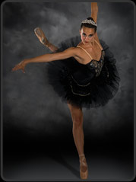
Alessandra graduated from GBT in 2001. That summer, Alessandra won the Bronze Medal Grishko Prize for Charm and Elegance at the Premio Roma competition in Rome, Italy. She also trained with Stanislav Issaev and went on to compete in the Premio Roma International Ballet Competition where she received third prize and the Grishko Prize for Charm and Elegance. Alessandra danced with Colorado Ballet for one season before joining Charlotte Ballet II and later, the main company. In 2008, after six years with Charlotte Ballet, Alessandra moved to Madrid, Spain, where she danced with the Victor Ullate Ballet. Alessandra has performed in George Balanchine’s Agon, Apollo, Midsummer Night’s Dream and Who Cares?; Jerome Robbin’s Fancy Free; Twyla Tharp’s Nine Sinatra Songs and The Golden Section; and as Mina in Mark Godden’s Dracula. She received a Princess Grace Award in 2005. She is in her 15th year at Charlotte Ballet.

FAITH CANDINO
After graduating in 2016, Faith moved to Richmond, VA to train in the Richmond Ballet Trainee program. At Richmond she has performed “Kingdom of the Shades”, excerpt from “LaBayadere” in 2016, and “The Nutcracker”(in Richmond and on tour in Norfolk, VA), as Snow corps and Flowers corps (2016 and 2017). She has performed in Balanchine’s “Divertimento No.15, duet #2”, an excerpt from “An American in Paris” (nontraditional) as a Flapper, set by Tara Penik, and modern/contemporary works by Starr Foster and Fernando Sabino.
She then joined the Virginia Reperatory Theater where she performed in “WEST SIDE STORY” with Virginia Repertory Theatre as Shark girl(Fransisca) AND Jet girl (Pauline)! (Original Jerome Robbins choreography.) She is also currently part of the Norwegian Creative Studios performing on Norwegian Cruise Ships around the world.

NANCY CASCIANO
After leaving GBT at the age of 14, having studied here from a very young age, Nancy was accepted on scholarship to the School of American Ballet and trained there for the next 5 years. There she performed in the annual Workshop performance for 3 years and was a part of many choreographic showcases. After graduating from SAB she was offered a position in the Professional Division with PNB where she performed in “Jewels” with the company. She was then offered an apprenticeship with the company in 2014, working with the corps in “The Nutcracker” and “Don Quixote” until she was promoted to PNB’s Corps de Ballet in 2015.

JESSICA COLLADO
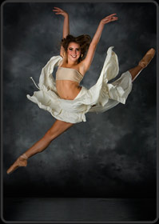
Jessica graduated from GBT in 2003. She is now a First Soloist with Houston Ballet. She became a member of Houston Ballet II and a student at Houston Ballet’s Ben Stevenson Academy where upon graduation in the Spring of 2004, she won the Michael Wasmund Memorial Award. Ms. Collado joined Houston Ballet as an apprentice in July 2004 and was promoted to a corps de ballet member in July 2005 and to a demi soloist in March, 2009. Ms. Collado has been featured in numerous roles by Kiri Kylian, Stanton Welch, Christopher Bruce, Nacho Duato, William Forsythe, George Balanchine, Jerome Robbins, Hans van Manen, Twyla Tharp, Jorma Elo, Christopher Wheeldon, Ben Stevenson, and Sir Kenneth MacMillian. In 2009, Ms Collado was declared one of Dance Magazine’s “25 To Watch.” Pointe Magazine named her performance of Christopher Bruce’s Grinning in Your Face “Top 10 Performances in 2011”. She continues to dance at Houston Ballet where was promoted to Principal Dancer in 2017.

ROBERT DEKKERS
Robert graduated from GBT in 2002. Named a “25 To Watch” artist for 2011 by Dance Magazine, Robert began his professional career at Ballet Arizona where he performed in works by George Balanchine, Twyla Tharp, Paul Taylor, Marius Petipa, August Bournonville, and Ib Anderson. After moving to San Francisco to work with ODC/Dance, Dekkers joined Company C Contemporary Ballet, and later, Diablo Ballet. He began choreographing in 2001. His first work was awarded the Monticello Award for Emerging Choreography, allowing him to attend RDA’s Craft of Choreography Conference on full scholarship. Since then, he has created dozens of new works, including “Toccare” in 2006 which was performed at the Ballet Builders Showcase in New York City and “Suite No. 2,” presented at the World Ballet Competition in Orlando; and “Believe,” 2003, which was performed at the Tanzsommer Festival in Vienna, Austria. In 2008, Dekkers was named Resident Choreographer of Novaballet, Arizona’s contemporary ballet company, where he created works including “AnOther,” 2008, “Milieu,” 2009, and “No One Does It Like You,” 2009. He is currently the resident choreographer of Diablo Ballet. In 2009, Dekkers founded Post:Ballet in San Francisco with the vision to create multidisciplinary collaborations that use dance as a means, not an end, to artistic expression. Roberts works closely with diverse artists to develop works that are presented through various mediums including film, photography, and live performance. He has created several new works for Post:Ballet including “The Happiness of Pursuit,” “Colouring,” “Ours,” “I need to be Touched,” “Me No You,” “Flutter,” and “B-Sides.” Robert also holds a business degree from Rio Salado College. PostBallet is now the official company of Berkley Ballet Theater. You can follow them online at postballet.org.

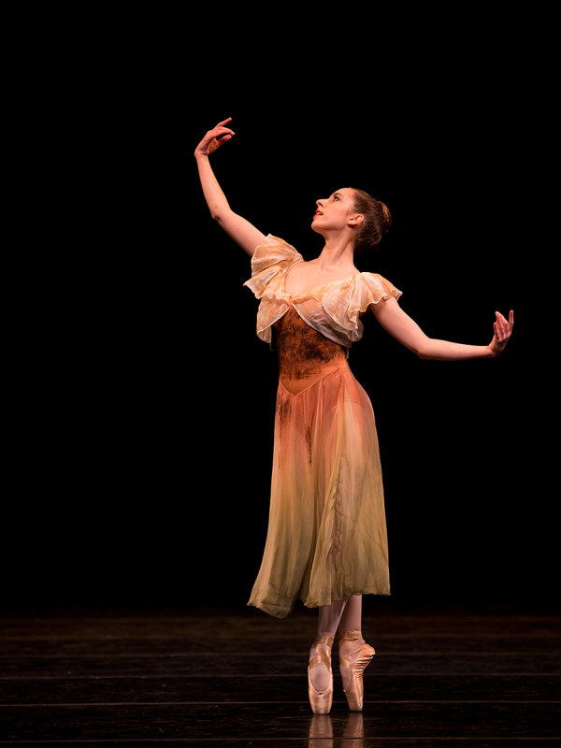
ABIGRACE DIPRIMA
Abigrace Diprima graduated from GBT in 2014. She went on to continue her ballet training at the University of North Carolina School of the Arts under Susan Jaffe and other renowned ballet instructors. She graduated in 2018 and has accepted a position as a corps de ballet member of Ballet Tucson for the 2018-19 season.

MAGGIE ELLINGTON
Maggie graduated from GBT in 2012 and graduated from Point Park University in Pittsburgh, PA on a Conservatory scholarship with a BFA in Ballet. She dances in the Conservatory of Performing Arts Dance Company. In 2012 she performed in the Erie Pennsylvania Ballet’s Nutcracker, and during 2013-2014 she performed in Nicholas Petrov’s “Romeo and Juliet” winter performances at the Pittsburgh Playhouse Theater in Pittsburgh. During her freshman year she became a Youth America Grand Prix New York City Finalist and placed 7th overall for “Contagion,” an ensemble choreographed by Garfield Lemonius. Maggie attended summer programs following high school with Alonso King’s LINES Ballet, San Francisco, CA (performing choreography by Lee-Wei Chao and Robert Sher-Machherndl, 2012 and Julia Steifel, 2013) and Ballet West, Salt Lake City, UT (studying under Adam Sklute, Rene Daveluy, Francois Perron 2014. She is currently teaching in the Atlanta area.

Hannah Freeman
Hannah graduated from GBT in 2017 and was a trainee with Charlotte Ballet for the 2017-2018 season. She has also attended summer courses with Boston Ballet, American Ballet Theatre in New York City, and Pennsylvania Ballet. She is in her second season at American Contemporary Ballet in Los Angeles, California.

JENNIFER HITE
Jennifer Hite, who graduated from GBT in 2012, graduated as a Dance Pedagogy major at Butler University’s Jordan College of the Arts in Indianapolis, Indiana in 2016. She accepted the position of Trainee with the Kentucky Ballet Theatre for the 2016-17 season. While she was a member of Butler Ballet Company, she performed in The Nutcracker, Cinderella, Sleeping Beauty, and Giselle, as well as the yearly Senior Choreography, Midwinter Festival and Student Choreography productions. In 2014 she performed with a select touring group for 25 days throughout Poland, Slovakia, Czech Republic and Austria. Jennifer was the Butler Community Art School’s Dance Division Coordinator; an active member of Butler’s dance fraternity Sigma Rho Delta; President of the student campus ministry, Converge; Archivist for sorority, Kappa Alpha Theta; a member of Best Buddies club and is a National Society of Collegiate Scholar member. Jennifer is the founder of City Ballet Studio in New York, New York and also teaches at the prestigious Broadway Dance Center. She also currently dances with Ballets with a Twist.

MARGARET HANNAH

Margaret graduated from GBT in 2001 where she had the opportunity to perform in Austria at the Tanzsommer Festival. She has received scholarships to Orlando Ballet, Boston Ballet, Ballet Austin and Burklyn Ballet Theatre where she was selected to perform at The Fringe Festival in Scotland there she danced the lead in both “Alice in Wonderland” and “The Little Mermaid”. Ms. Hannah’s professional experience includes principal roles with Manassas Ballet Theater where she was also invited to choreograph for the company under the direction of Amy Wolfe. She also preformed principal roles with Ballet Theatre of Maryland and in 2009 she was promoted to Ballet Mistress, under the direction of Dianna Cuatto. Her roles include Dew Drop, Snow Queen, and the Sugar Plum Fairy in the Nutcracker, Cinderella in Cinderella, Odette in Swan Lake, Queen of the Dryads in Don Quixote, Dawn in Coppelia, and Carabosse in Sleeping Beauty. Margaret teaches beginner through professional classes according to the Vaganova syllabus and has been invited to teach and choreograph throughout Maryland and Virginia. She is currently seeking her degree in dance education and teaches at The Dance Academy in Maryland.

PABLINA LOPEZ
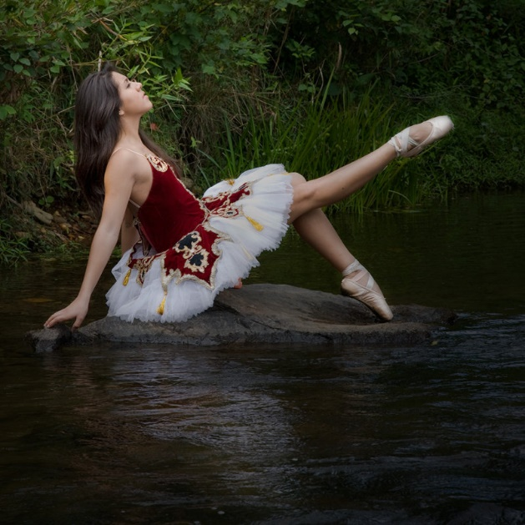
Pablina Lopez is a native of Atlanta and a proud Alumna of the Gwinnett Ballet Theatre. She has had the honor of performing with the Kennesaw State University Dance Company for four consecutive seasons in venues such as The John F. Kennedy Center for the Performing Arts, Cobb Energy Performing Arts Centre, and Rialto Center for the Arts. Apart from GBT she has danced and trained in programs with the Atlanta Ballet and El Ballet Municipal de Santiago in Chile. She graduated with a Bachelor of Arts in Dance and Bachelor of Science in Communications from Kennesaw State University in Spring of 2015. Her most recent roles include Cats and Young Frankenstein with the Atlanta Lyric Theatre. You can see her in the next Aurora Theater production of On Your Feet! From March 8-April 12, 2020.

BIANCA MELIDOR
Bianca Melidor graduated from GBT in 2014. She attended Point Park University in Pittsburgh, PA where she received intense dance training from amazing teachers. She has had the opportunity to participate in some choreographic projects for performances, and many of those projects have been with the Point Park Impulse hip hop team. She graduated in 2018 and is now dancing with Dallas Black Dance Theater: Encore!

LAUREN PAPPAFOTIS
Lauren Pappafotis started dancing at the age of four. She studied at Gwinnett Ballet Theatre where she learned various styles of dance including ballet, jazz, modern and hip-hop. During high school she had the opportunity to attend several summer intensives including Joffrey Midwest and Nashville Ballet. Lauren attended the University of West Georgia her freshman year of college where she was a part of the West Georgia Dance Team. While there, she danced alongside the marching band during all home football games. For the rest of her college career she studied dance at Kennesaw State University. She graduated with a Bachelors of Arts in Dance with a concentration in Ballet. After graduation, Lauren joined the Glads Girls dance team for their inaugural season. Currently, Lauren is a Stage Manager at Stone Mountain Park and during the Christmas Season there she had the opportunity to perform as the Snow Angel. She also teaches at Expressions In Motion.

